Guide to Simplified Retroperitoneal SP Access for Ureteral Recon
- Position the patient with a small bump (1L IV fluid bag wrapped in a blanket) under the ASIS, on the operative side, supine or in low lithotomy depending on urethral anatomy. Tuck and pad arms.
- Start with flexible ureteroscopy and advance a guidewire + ureteroscope up to the stenosis in the ureter. No intra-ureteral ICG.
- Place a 14 French Foley catheter alongside the ureteroscope. Final Foley will be 18 French.
- Mark the ipsilateral ASIS and measure 2 finger breadths above. Mark a 3cm transverse incision slightly medial to the midpoint of the ASIS.
- Clear off the external oblique muscle fascia, place stay sutures, incise the fascia and identify the internal oblique fascia, incise through and identify the transversus abdominis fascia. This must also be divided. At this point, finger sweep through the transversalis fascia to the ipsilateral ASIS, hook the retroperitoneal fat and peritoneum, and sweep medially. Place the small beach ball access port.
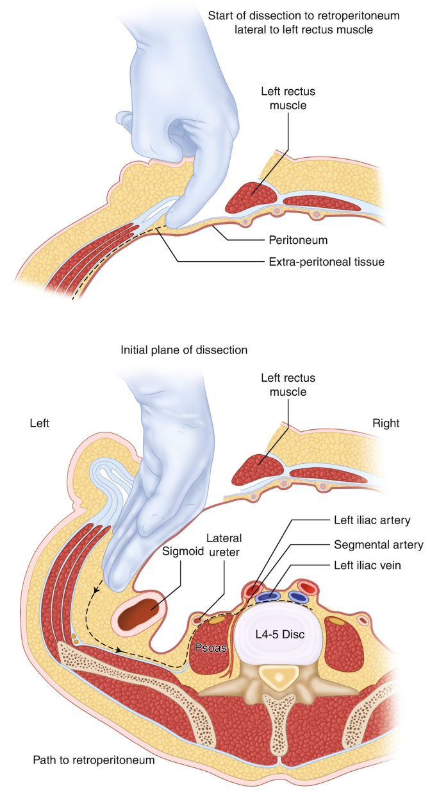

Positioning and marking (patient in lithotomy)
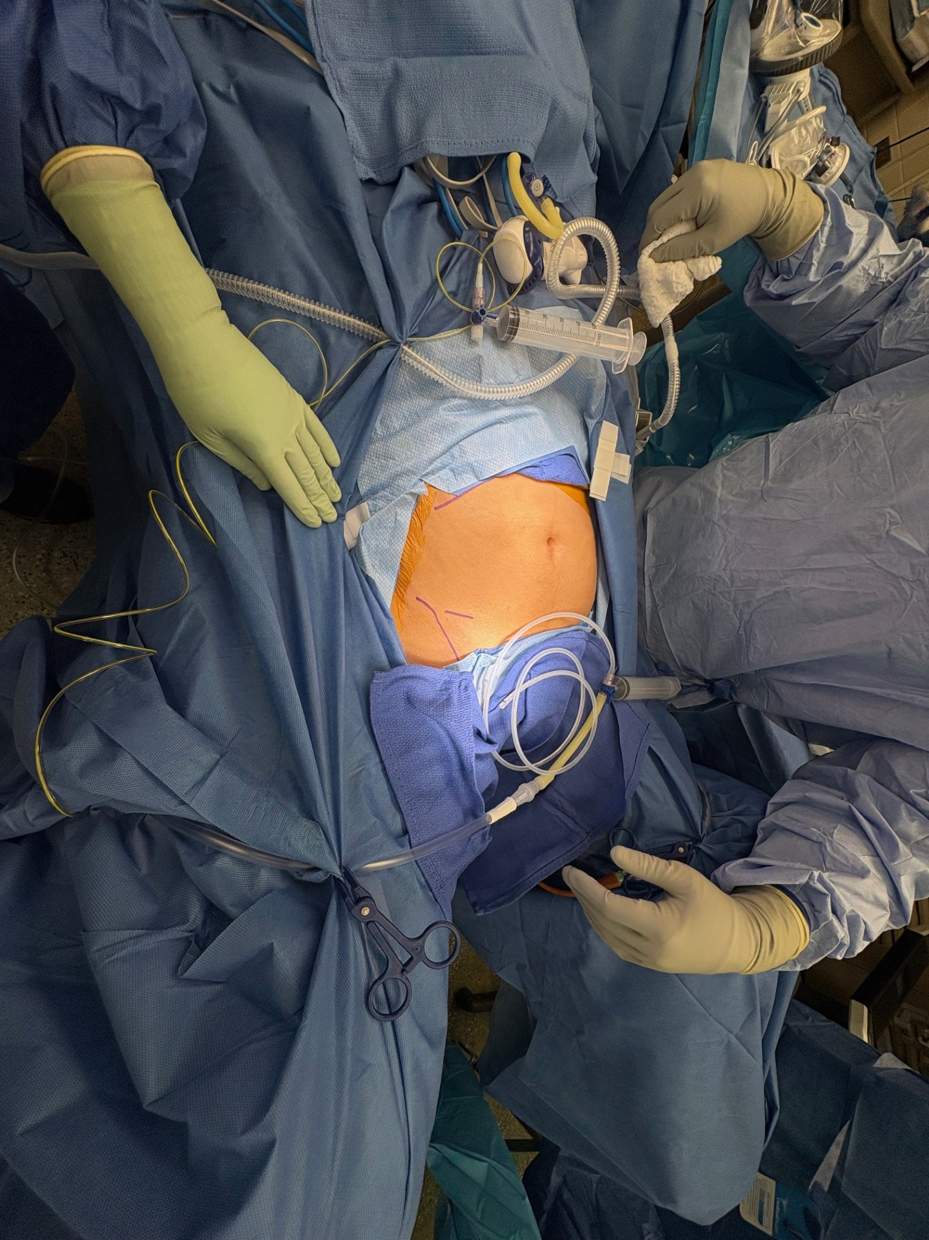
External oblique fascia
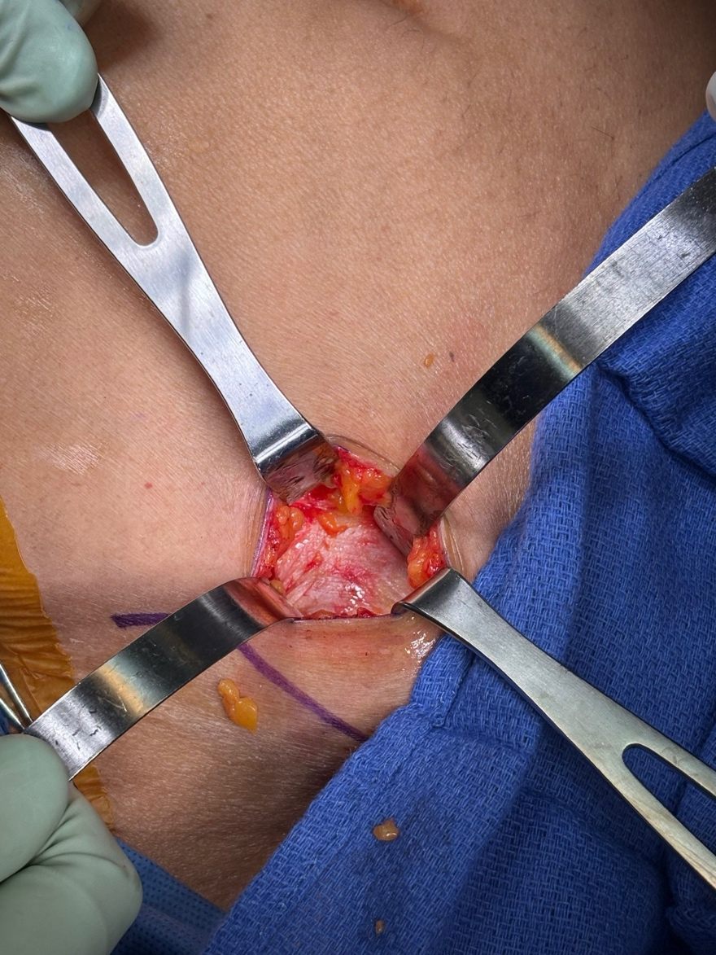
Internal oblique fascia
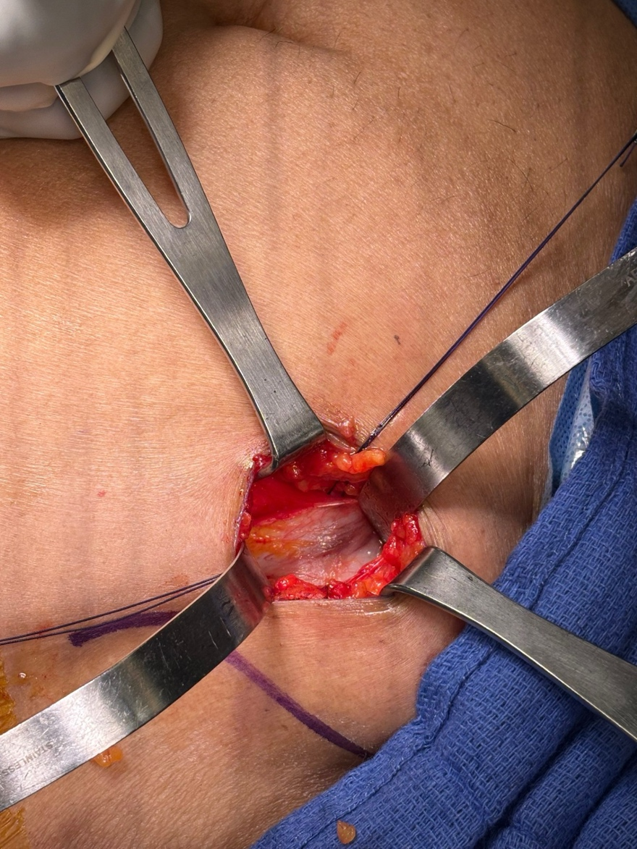
Transversus abdominis fascia (not always well developed)
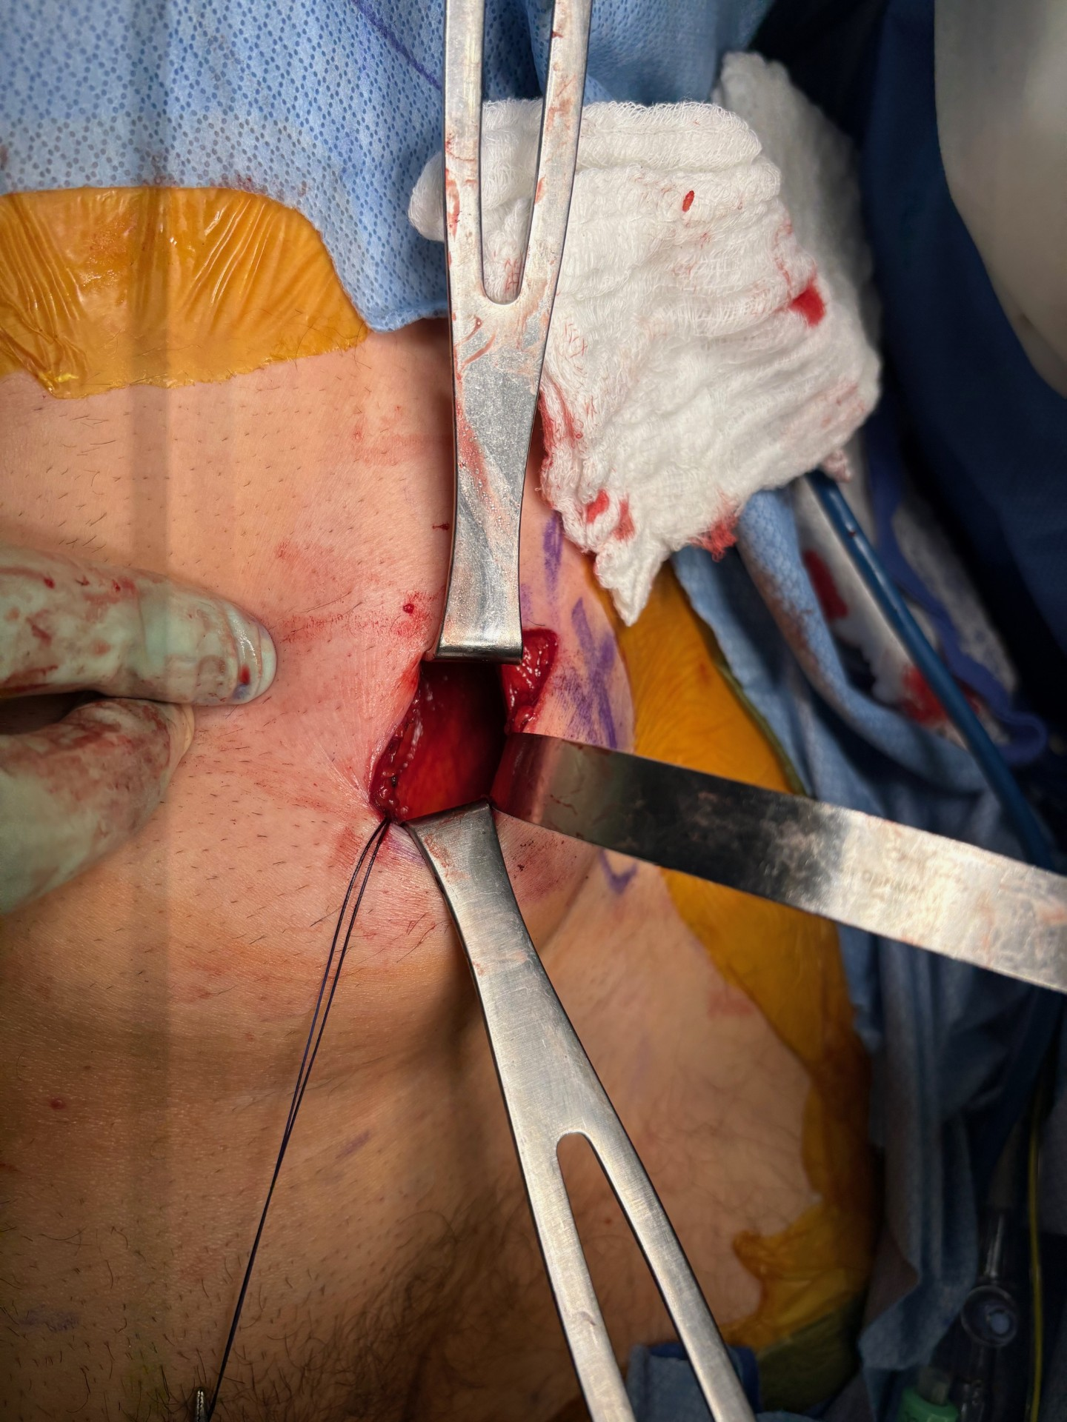
Psoas plane (low BMI)
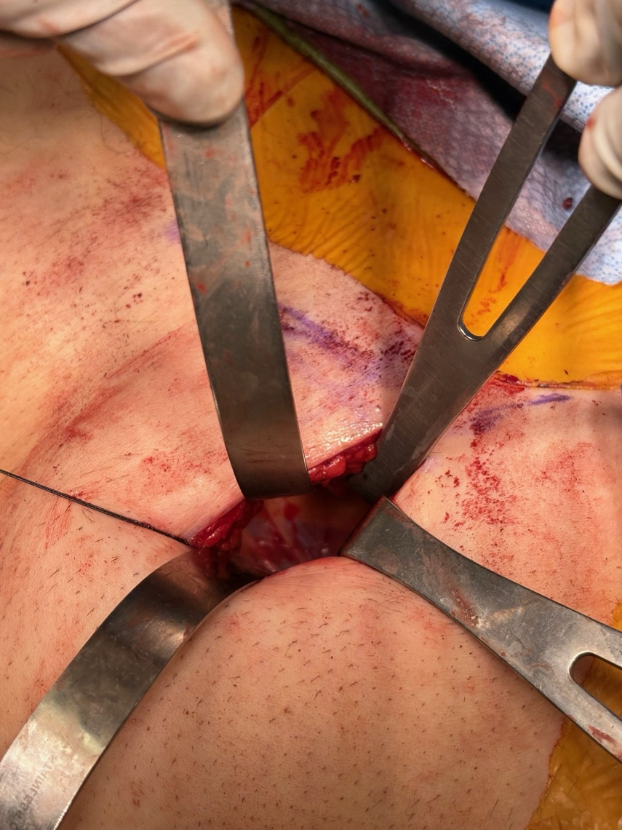
Psoas plane (higher BMI)
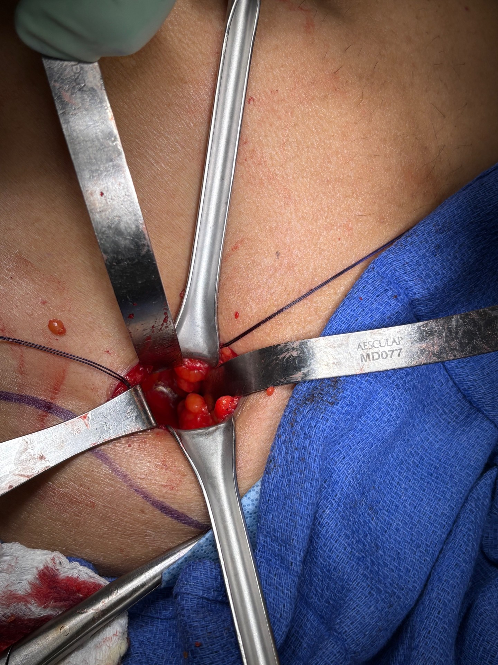
- Set up the custom suction irrigator with cysto tubing, suction tube, Christmas tree adapter, 3 way plastic stopcock, 15 French round Blake drain cut to size, 2-0 silk holding suture, 50cc Luer lock syringe.
- If a nephrostomy tube is present, connect long yellow extension tubing to it, with a 3 way stopcock and 50cc Luer lock syringe on the sterile field.
- Insufflate the retroperitoneum with low flow, pressure 8mmHg AirSeal and dock the robot.
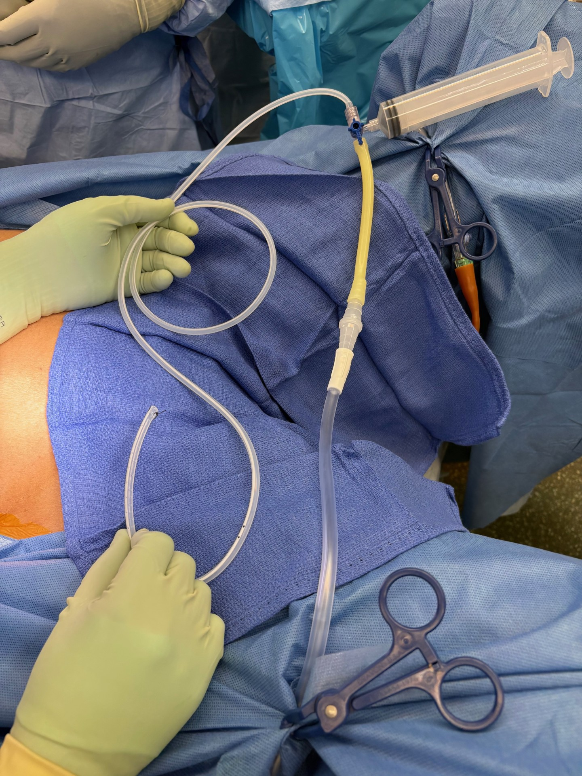

Final Setup
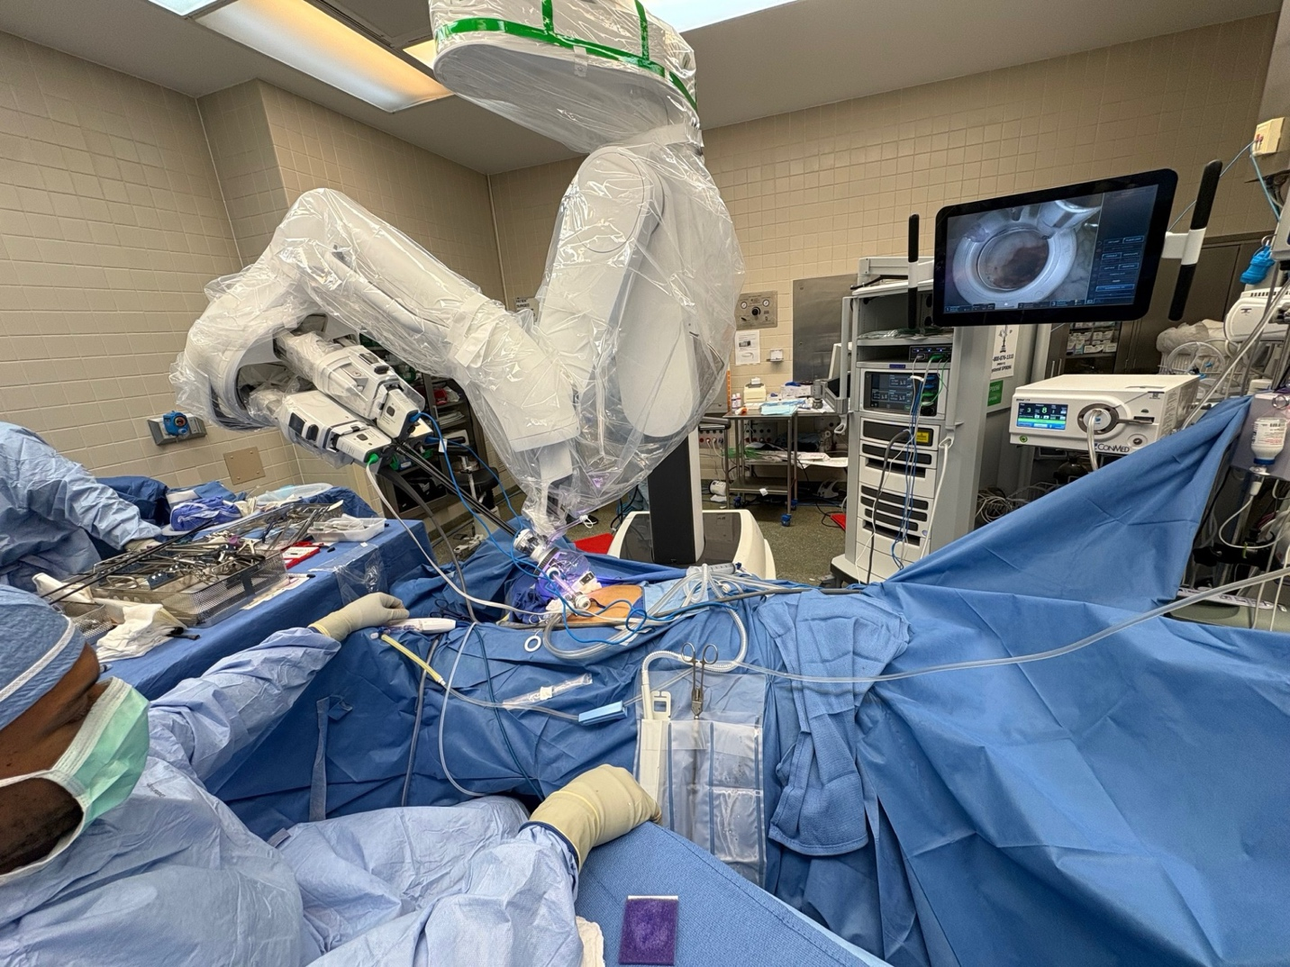
Initial Robotic View
